COS225 Assignment #10 Name: Nicholas Soucy
Due: Friday 4/27/18

Part I. (20 pts.)

#1. (10 pts.) One implementation of a hash table uses the linear probing insert and search techniques. Assume valid entries are positive and the empty table is initialized with 0. Use the provided hash function.

int hash (int item) // POST: return hash index of item
{ return item % 13; }

Show the state of the array after inserting values: 10 45 26 5 70 13 18 25

26 | 13 |  |  |  | 5 | 45 | 70 | 18 |  | 10 |  | 25
0 1 2 3 4 5 6 7 8 9 10 11 12

How many probes are required to determine that value 13 is in the hash table? 2

How many probes are required to determine that value 38 is not in the hash table? 4

#2. (10) The hash table below is implemented as an array of linked lists and uses the chaining method of collision resolution.

a. Assume the hash function used is hash (target) = target % 5 Draw the state of the hash table after inserting the following items in order.

13 20 14 30 8 6

table[0] | 20 | 30
table[1] | 6
table[2]
table[3] | 13 | 8
table[4] | 14

How many probes are required to determine that value 13 is in the hash table? 1

How many probes are required to determine that value 38 is not in the hash table? 3

Part II (80 pts.)

Hash 1:
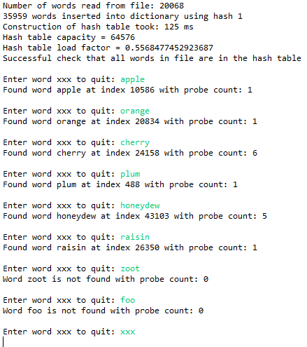

Hash 2:
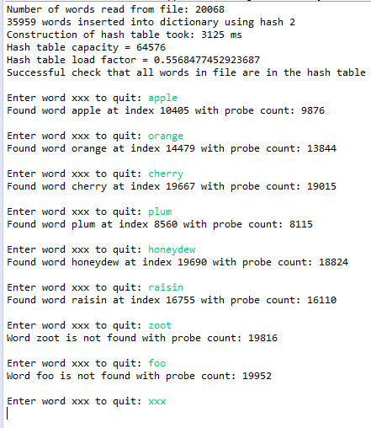

Clearly hash fuction 1 is vastly superior to hash 2. This is caused by the ‘seed’ object added in the hash 1 function. This prime number that is multiplied by the sum allows the data in the hash table to be more uniformly distributed. This allows for less collisions to occur, which in turn allow the probings to take significanly less time.

